Wellbrook School: PSHE & RSE Policy

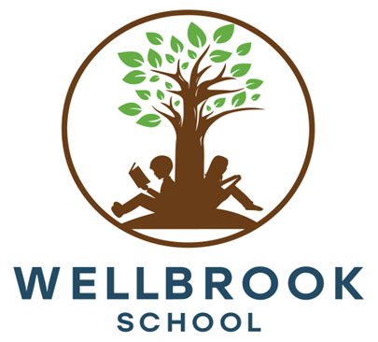
Complied: | April 2024
Reviewed by: | C. Howells
Last Review Date: | March 2025
Approved by: | Governance Committee
Approval Date: | March 2025
Next Review date: | March 2026
Version Number: | Version 1
Policy Number | 11

Policy Statement & Rationale
At Wellbrook School, we strive to provide every child with the opportunity to unlock their potential. We honour and celebrate their individuality and tailor our instruction to their personal needs. Our goal is to nurture self-confidence and provide students with the support necessary to help them reach heights they didn’t think were possible. We want parents to imagine the possibilities when they walk through our doors and be filled with hope as they see their children achieve beyond their expectations. We strive to be a place where children feel they belong and can thrive.
This policy sets out the school’s approach to Personal, Social, Health and Economic Education (PSHE) and Relationships and Sex Education (RSE) delivery. It includes drugs education. This policy was compiled using guidance from the DfE guidance - Relationships Education, Relationships and Sex Education (RSE) and Health Education.
PSHE education provides a significant contribution to the schools’ responsibility to:
- promote children and young people’s wellbeing
- promote community cohesion within the school
- provide relationships and sex education.

The PSHE and RSE programme aims to develop:
- Successful learners who enjoy learning, making progress and achieving
- Confident individuals who are able to live safe, healthy, and fulfilling lives
- Responsible citizens who make a positive contribution to society.

Pupils are also taught explicitly about British Values which are defined as:
- Democracy & the rule of law
- Individual liberty
- Mutual respect
- Tolerance of those of different faiths and beliefs.

These values are taught explicitly through Personal, Social, Health and Emotional Education (PSHE), Character Education, as well as through the school’s broad and balanced curriculum. Parents will be consulted about this policy when the school opens during the referral and induction process and the revised policy will be made available through the school website.

Legislation (Statutory Regulations and guidance)
Under the Education Act 2002, all schools must provide a balanced broadly-based curriculum which:
- Promotes the spiritual, moral, cultural, mental, and physical development of pupils at the school and of society
- Prepares pupils at the school for opportunities, responsibilities, and experiences of later life
The 2006 Education and Inspections Act placed a duty on Governing Bodies to:
- Promote the wellbeing of pupils at the school

The Education (Independent School Standards) Regulations (2014) state that proprietors of independent schools must ensure that a written policy on the curriculum, supported by appropriate plans and schemes of work, is drawn up and implemented effectively and that it should provide for, amongst other matters: personal, social, health and economic education which:
- reflects the school’s aim and ethos; and
- encourages respect for other people, paying particular regard to the protected characteristics set out in the 2010 Act (1).

Revised Department for Education statutory guidance states that from September 2020 all schools must deliver:
- Relationships Education (Primary) and Relationships and Sex Education (Secondary).

Safe and Effective Practice
PSHE and RSE often draw on pupils’ real-life experiences. A safe and supportive learning environment will be created by establishing ground rules in each context for the delivery of subject material. They have a right to expect schools to provide a safe and secure environment. Any fears or worries they bring into the classroom should not go unnoticed. Staff delivering PSHE and RSE will ensure the pupils, who indicate they may be at risk, get appropriate support by liaising with the Headteacher and adhering to the school’s Safeguarding Policy.

Confidentiality
Pupils will be made aware that some information cannot be held confidentially and will be informed that, if certain disclosures are made, the information may be disclosed to the Designated Safeguarding Lead.
Teachers need to be aware that effective sex and relationship education, which brings an understanding of what is and is not acceptable in a relationship, can lead to disclosure of a child protection issue. If a member of staff suspects that a child is a victim of abuse, or they have reason to believe that he/she is at risk of abuse they must report concerns to the DSL.
Staff must be aware that our pupils are particularly vulnerable to abuse due to SEND and other concerns. It is only in the most exceptional circumstances that we will handle information without parental knowledge.
Staff must ensure that pupils are aware of the school’s confidentiality policy and how it works in practice. Pupils are to be:
- reassured that their best interests will be maintained
- encouraged to talk to their parents or carers and giving them support to do so
- told that teachers cannot offer unconditional confidentiality and that if confidentiality has to be broken, they will be informed first and then supported as appropriate
- informed of sources of confidential help, for example, GP or local young person’s advice service.

Personal disclosures

Effective RSE should enable and encourage young people to talk to a trusted adult if they are having sex or contemplating doing so. It is desirable, although not always possible, that that person should be their parent or carer. The law allows health professionals to see and, in some circumstances, to treat young people confidentially, and part of this process includes counselling and discussion about talking to parents.
In order to be able to take responsibility for their actions, young people need to be more generally aware of the law in relation to sexual activity and local confidential services. There may be rare occasions when a member of staff is directly approached by a child underage who is sexually active or is contemplating sexual activity. This should be viewed as a child protection issue and raised with DSL. There may be cases where a teacher learns from an under 16-year-old that they are having, or contemplating having, sexual intercourse. In these circumstances we will take steps to ensure that:
- wherever possible, the young person is persuaded to talk to their parent or carer
- any child protection issues are addressed
- the child has been adequately counselled and informed about contraception, including precise information about where young people can access contraception and advice services.
In the most exceptional cases we may be in the position of having to handle information without parental knowledge, and where younger pupils were involved, this would be grounds for serious concern.
Outside the teaching situation, health professionals such as a visiting nurse can:
- give one-to-one advice or information to a pupil on a health-related matter including contraception
- exercise their own professional judgement as to whether a young person has the maturity to consent to medical treatment including contraceptive treatment.

Equality of Opportunity
Classroom practice and pedagogy will consider pupils’ age, ability, cultural background, SEND needs and will be adjusted to enable all students to access the learning. PSHE and RSE education will be used as a way to address diversity issues and to ensure equality for all by addressing contextual issues identified during 1 to 1 pastoral sessions and through surveys.
PSHE and RSE delivery is designed to comply with the Equality Act 2010. Provisions within the Equality Act allow the School to take positive action, where it can be shown that it is proportionate, to deal with particular disadvantages affecting one group because of protected characteristics.
The school will ensure that all teaching is sensitive and age appropriate in approach and content. At the point at which the school considers it appropriate to teach LGBT content, they should ensure that this subject matter is fully integrated into their programmes of study for this area of the curriculum rather than delivered as a stand-alone unit or lesson. The school will determine how they do this and expect all pupils to have been taught LGBT content at a timely point as part of this area of the curriculum.

Definition of Relationships and Sex Education (RSE)
Relationships and sex education (RSE) is learning about the emotional, social, and physical aspects of growing up, relationships, sex, human sexuality, and sexual health. It should equip children and young people with the information, skills, and positive values to have safe, fulfilling relationships, to enjoy their sexuality and to take responsibility for their sexual health and well-being.

RSE is an entitlement for all children and young people and must:
- Be accurate and factual, covering a comprehensive range of information about sex, relationships, the law, and sexual health, in order to make informed choices. In schools this should be part of compulsory curriculum provision
- Be inclusive in terms of gender, sexual orientation, disability, ethnicity, culture, age, religion or belief or other life-experience particularly HIV status and pregnancy
- Include the development of skills to support healthy and safe relationships and ensure good communication about these issues
- Promote a critical awareness of the different attitudes and views on sex and relationships within society such as peer norms and those portrayed in the media
- Provide opportunities for reflection in order to nurture personal values based on mutual respect and care
- Be part of lifelong learning, starting early in childhood and continuing throughout life. It should reflect the age and level of the learner
- Ensure children and young people are clearly informed of their rights such as how they can access confidential advice and health services within the boundaries of safeguarding
- Be relevant and meet the needs of children and young people, and actively involve them as participants, advocates, and evaluators in developing good quality provision
- Be delivered by competent and confident educators
- Be provided within a learning environment which is safe for the children, young people and adults involved and based on the principle that prejudice, discrimination and bullying are harmful and unacceptable.

Curriculum Design & Delivery
The curriculum is designed around active engagement in learning, rather than passively receiving information. Pupils will be given opportunities to consider and clarify their values and beliefs and to rehearse and develop enquiry and interpersonal skills.
We have chosen to follow the PSHE Association curriculum. An outline of content to be covered is provided at the end of this policy. Delivery of this curriculum will be customised as outlined below.
The DfE guidance about relationship, sex and health education states that “…schools should ensure that their teaching is sensitive, age-appropriate, developmentally appropriate and delivered with reference to the law.” The guidance outlines what pupils should know by the end of primary and secondary school. We will use this information as a starting point and identify what’s developmentally appropriate and what should be taught with sensitivity based on our knowledge of pupils needs and contexts and with input from relevant professionals.

Responsibilities
Headteacher: To coordinate the delivery of those aspects of PSHE which are delivered through 1 to 1 pastoral sessions
PSHE Teachers: To thoroughly prepare for PSHE lessons and deliver them effectively

Parents/carers’ right to withdraw their child

Parents/carers cannot withdraw their child from relationships education.
Parents/carers of pupils in secondary can withdraw their child from sex education.
At secondary school level parents will be able to withdraw their child from sex education (other than the sex education which sits in the curriculum as part of science). The school will respect the parents’ request to withdraw the pupil up to and until 3 terms before the pupil turns 16. After that point, rather than be withdrawn, if the pupil wishes to receive sex education, the school will make the provision.
If a pupil is withdrawn from sex education, the school will ensure the pupil receives purposeful education during the period of withdrawal.
If a pupil at the appropriate age opts in to receive sex education - before granting such a request, the Headteacher will meet with parents and, as appropriate, with the pupil to ensure their wishes are understood and to clarify the nature and purpose of the curriculum.
The school will keep a record of all such decisions.

Intended Outcomes
As a result of our PSHE and RSE programme, pupils will:
- Develop the knowledge, skills, and attributes they need to manage their lives now and, in the future
- Learn to make responsible decisions and focus on the importance of building healthy and positive relationships
- Learn to recognise and manage risk and take increasing responsibility for themselves and their actions
- Understand the importance of wellbeing and how to tackle issues that can affect their ability to learn
- Be encouraged to make positive contributions to their families, schools, and communities
- Explore differences and learn to value diversity in all its forms
- Reflect on their own individual values and attitudes
- Identify and articulate feelings and emotions and manage difficult situations positively

Monitoring and Assessing
The PSHE & RSE curriculum will be reviewed annually as part of the whole school curriculum review or when relevant guidance makes this necessary.

Counselling Services
Pupils are made aware of counselling and information services and offered appropriate support.

Outside Speakers & Visiting Professionals
Visiting speakers and professionals should work to the aims, objectives, and values that the school policy promotes. Please refer to the Safeguarding policy for details of procedures for Visiting Speakers

Annex A: Our PSHE & RSE Curriculum

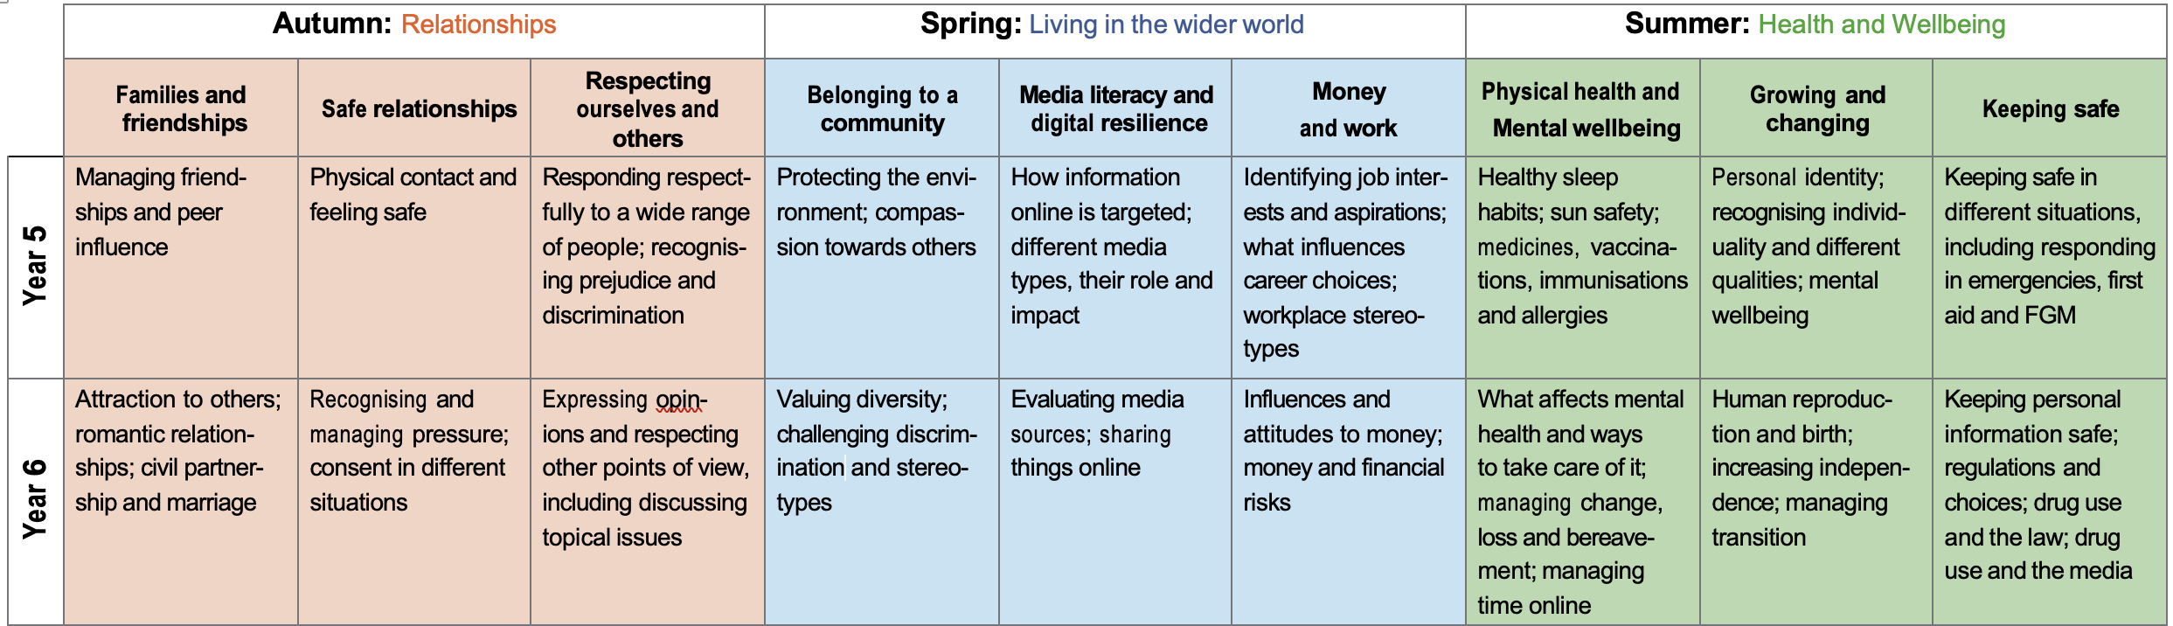
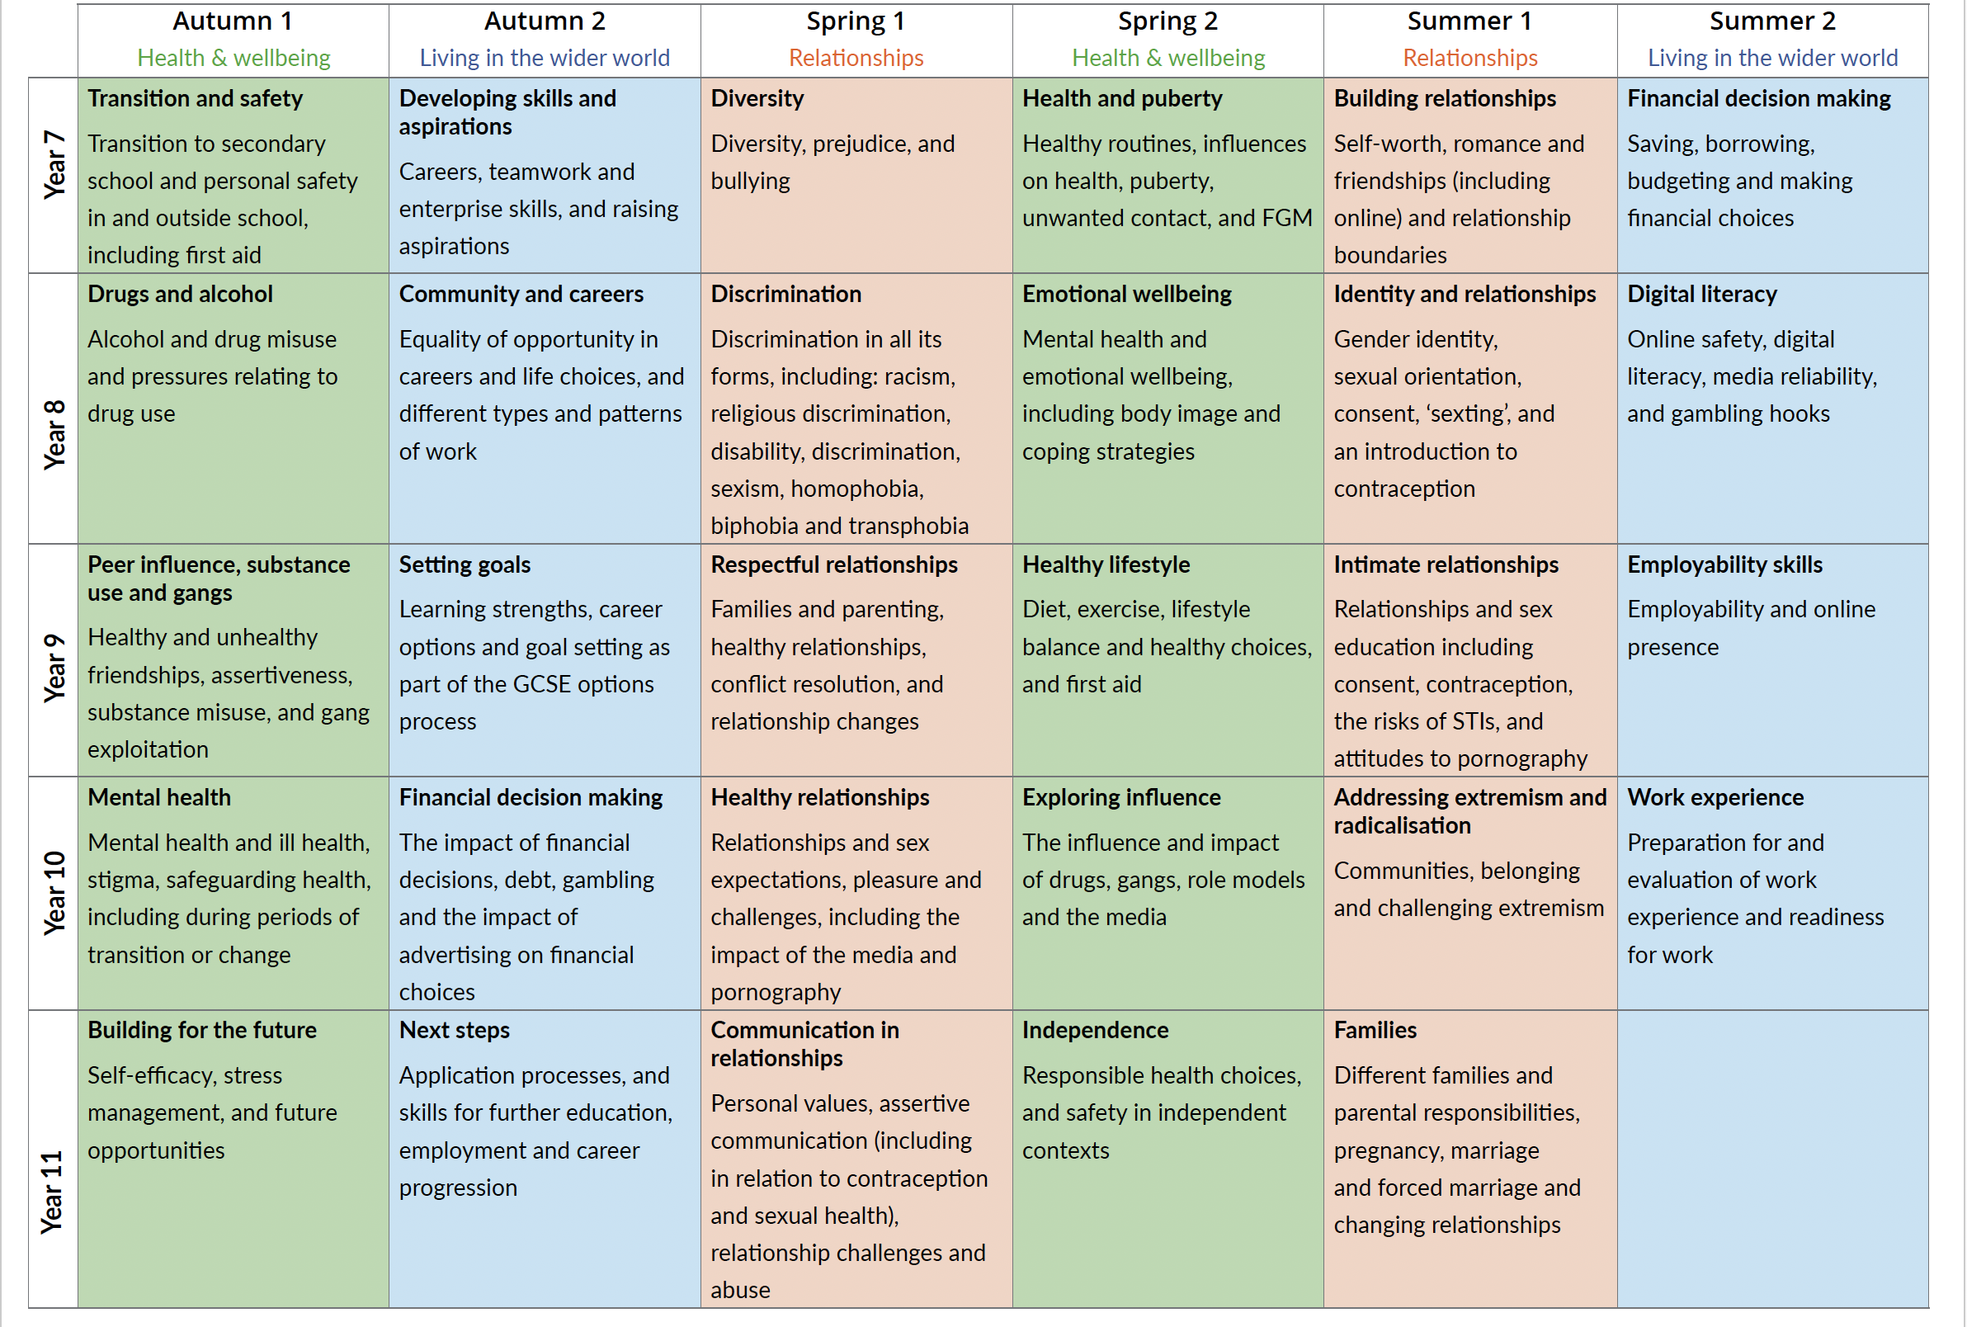
Annex B: Parent/Carer RSE Consultation Letter
Dear Parent/Carer

As you may already be aware, from September 2020, the Department for Education made Relationships Education compulsory in primary schools and Relationships and Sex Education (RSE) compulsory in secondary schools.

As part of our school’s wider Personal, Social and Health Education (PSHE) programme, your child will receive lessons on relationships, and if they are in of secondary age, they will also receive sex education.

Schools are required to consult with parents when developing and reviewing their policies for Relationships Education and RSE, which will inform schools’ decisions on when and how certain content is covered. Please find our policy attached/enclosed. It has a section which outlines what will be taught in PSHE, including relationships and sex education.
The purpose of the curriculum is to provide knowledge and understanding of safe and healthy relationships based on respect. This is to encourage the development of safe and healthy relationships throughout life. The subject is designed to help children from all backgrounds build positive and safe relationships, and to thrive in modern Britain.
If your child is of secondary age, you do have a right to withdraw them from part or all of the sex education delivered as part of RSE (but not what’s delivered as part of the science curriculum). If you choose to withdraw your child, please make that clear on the “Parent/Carer RSE Consultation Form” which is attached/enclosed. We will invite you to discuss your request to make sure we understand your wishes and that you are clear about the nature of this curriculum. After the discussion your request will be granted. However, from the time your child is three terms away from turning 16, they have the right to choose to receive sex education rather than be withdrawn.

There is no right to withdraw from Relationships Education and we believe the content of these subjects – such as family, friendship, safety (including online safety) – are important for all children to be taught. We hope that you share our enthusiasm for the successful implementation of the PSHE curriculum which we feel will benefit all of our pupils.

Please complete the consultation form to give us your feedback about the relationship and sex education curriculum.
You are welcome to contact me to discuss the programme further.

Yours sincerely,

Annex C: Parent/Carer RSE Consultation Form
Please read the PSHE & RSE policy and the Parent/Carer Consultation letter before completing this form
- This is what I think about what the policy states under the headings:

Heading | Agree (please tick) | Disagree (please tick) | If you disagree, please give us your feedback
Safe and Effective Practice
Confidentiality
Personal Disclosures
Curriculum Design & Delivery

- Parent/Carer Right to Withdraw from Sex Education

After looking at the overview of what will be covered as part of sex education, I would like to withdraw my child _______________________________

from part / all (please circle as appropriate) sex education provided as part of RSE.

If you have chosen to withdraw your child from part of the sex education, please state which parts: _________________________________________

__________________________________________________________________________________________________________________________

Name: __________________________________________________ Signature: ________________________________________________________

Relationship to child: _____________________________________ Date: _____________________________________________________________

Annex D: Template for Secondary Age Pupils to Opt-in to Sex Education

Parents/carers of children in secondary school, have a right to withdraw them from part or all of the sex education delivered as part of RSE.

Your parent/carer has chosen to exercise this right.

However, from the time a child is three terms away from turning 16 onwards, they have the right to choose to receive sex education rather than be withdrawn.

This form has been presented to you because you are choosing to exercise your right.

I, ___________________________________________ would like to receive sex education rather than be withdrawn.

Signature: ____________________________________

Date: _________________________________________

